Student Performance Analysis – Power BI

1. Project Title
Student AI Usage and Academic Performance Analysis Dashboard

2. Project Overview
This project analyzes the relationship between Artificial Intelligence (AI) usage and student academic performance using Power BI. The dashboard provides insights into study habits, AI dependency, attendance, academic scores, and overall student performance. The goal is to understand how AI tools influence learning outcomes and educational success.

3. Objective
The primary objectives of this project are:
- Analyze student academic performance.
- Examine AI usage patterns among students.
- Measure the impact of AI dependency on academic results.
- Identify factors influencing student success.
- Provide actionable insights for educators and students.

4. Dataset Description
The dataset contains information about students, their academic performance, study behavior, AI usage patterns, and engagement levels.

Key Attributes
Column Name | Description
student_id | Unique student identifier
age | Student age
gender | Student gender
grade_level | Academic level
study_hours_per_day | Daily study hours
uses_ai | AI usage indicator
ai_usage_time_minutes | Daily AI usage time
ai_tools_used | AI tools utilized
ai_usage_purpose | Purpose of AI usage
ai_dependency_score | Dependency on AI
ai_generated_content_percentage | AI-generated work percentage
ai_prompts_per_week | Weekly AI prompts
ai_ethics_score | AI ethics awareness score
last_exam_score | Most recent exam score
assignment_scores_avg | Average assignment score
attendance_percentage | Attendance percentage
concept_understanding_score | Concept understanding level
study_consistency_index | Study consistency score
improvement_rate | Academic improvement rate
sleep_hours | Daily sleep hours
social_media_hours | Social media usage
tutoring_hours | Tutoring hours
class_participation_score | Class participation score
final_score | Overall academic score
passed | Pass/Fail status
performance_category | Student performance level

5. Tools Used
- Microsoft Power BI Desktop
- Power Query Editor
- DAX (Data Analysis Expressions)
- Data Modeling
- Interactive Visualizations

6. Data Preparation
The following preprocessing steps were performed:

Data Cleaning
- Checked data quality.
- Verified data types.
- Removed inconsistencies.
- Handled missing values if present.

Data Transformation
- Converted fields into appropriate formats.
- Created calculated measures using DAX.
- Generated performance metrics for analysis.
Data Modelling
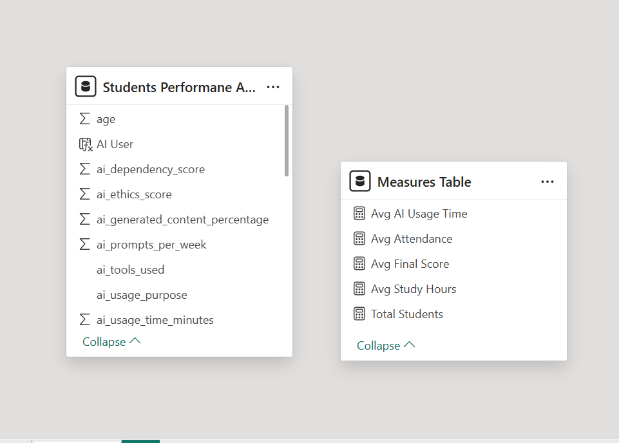

7. Key Performance Indicators (KPIs)
The dashboard includes:
- Total Students
- Average Final Score
- Pass Rate (%)
- Average Study Hours
- Average Attendance
- Average AI Usage Time

8. Dashboard Visualizations

1. KPI Cards
Display overall student statistics and performance indicators.

2. AI Users Distribution (Pie Chart)
Shows the proportion of students using AI versus non-AI users.

3. Performance Category Distribution
Displays the distribution of Low, Medium, and High performers.

4. Final Score by Grade Level
Compares academic performance across different grade levels.

5. AI Usage Purpose Analysis
Shows how students use AI tools for learning activities.

6. AI Tools Usage Analysis
Highlights the most frequently used AI tools.

7. AI Dependency vs Final Score (Scatter Chart)
Analyzes the relationship between AI dependency and academic performance.

8. Study Hours vs Final Score
Measures the effect of study habits on academic success.

9. Gender-wise Performance Analysis
Compares performance distribution among different genders.
Dashboard
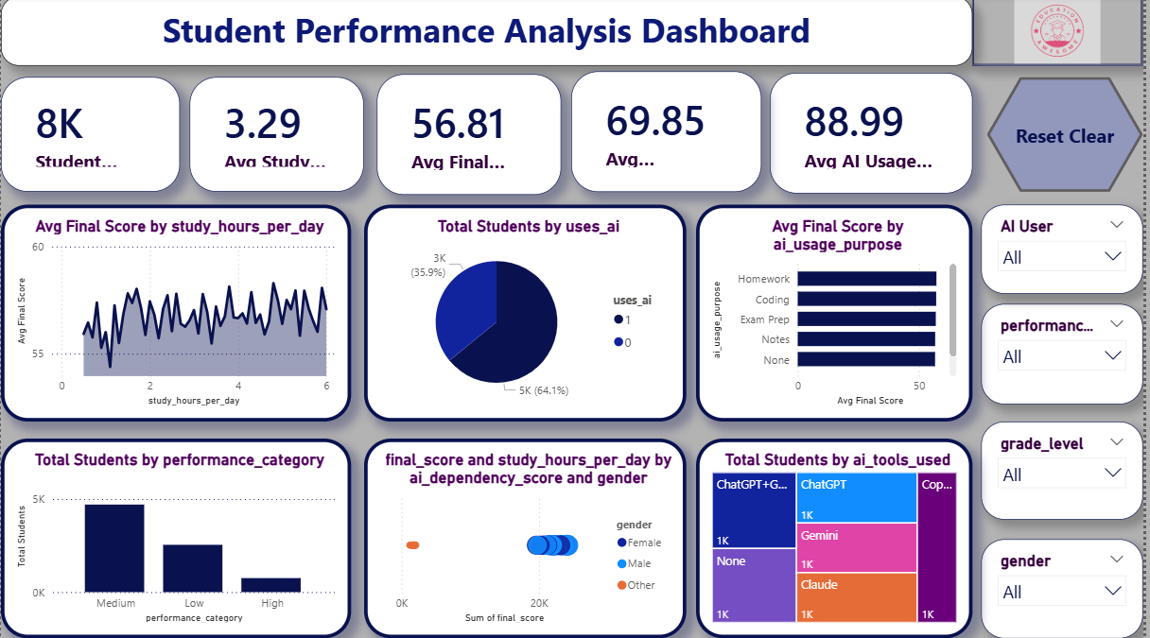

9. Dashboard Features
- Interactive Filters (Slicers)
- Dynamic Cross Filtering
- Performance Monitoring
- User-Friendly Design
- Real-Time Data Exploration

Slicers Used
- Gender
- Grade Level
- Performance Category
- AI Usage Purpose
- AI Tools Used
- Passed Status

10. Key Insights
- Students with higher study hours generally achieve better academic results.
- Moderate AI usage can support learning and improve productivity.
- Excessive AI dependency may negatively affect concept understanding.
- Attendance has a significant influence on final scores.
- Students with consistent study habits tend to perform better academically.
- AI tools are commonly used for notes preparation, coding assistance, homework, and exam preparation.

11. Business Value
This dashboard helps:

Educational Institutions
- Monitor student performance.
- Understand AI adoption trends.
- Improve academic support strategies.

Teachers
- Identify students needing assistance.
- Track learning behaviors.
- Evaluate study effectiveness.

Students
- Assess learning habits.
- Improve study consistency.
- Use AI responsibly and effectively.

12. Conclusion
The Student AI Usage and Academic Performance Dashboard provides valuable insights into the relationship between AI-assisted learning and academic achievement. By combining academic, behavioral, and AI-related factors, the dashboard supports data-driven decision-making for students, educators, and institutions. The project demonstrates how Power BI can transform educational data into meaningful and actionable insights.

Technologies Used
- Power BI Desktop
- Power Query
- DAX
- Data Visualization
- Data Analytics
Project Type: Educational Analytics Dashboard

